

**SCHOOL OF COMPUTER SCIENCE AND ENGINEERING**

**Master of Information Technology**

COMP 9900 Project Report

An Accommodation Booking Web Portal

|  |  |
| --- | --- |
| Group Name:KDY | |
| Zhenxi Xiao | z5202238 |
| Back-end Developer | zhenxi.xiao@student.unsw.edu.au |
| Xiaoyan Liu | z5203746 |
| Front-end Developer | Xiaoyan.liu@student.unsw.edu.au |
| Yitao Luo | z5220929 |
| Back-end Developer | yitao.luo@stdent.unsw.edu.au |
| Huiting Tu | z5211672 |
| Front-end Developer | h.tu@student.unsw.edu.au |
| Zhidong Luo | z5181142 |
| Scrum Master | zhidong.luo@student.unsw.edu.au |

Submitted date: April 26th, 2020

Table of Content

1. Background 1

2. System design 1

2.1 Searching 1

2.2 Booking 1

2.3 Advertising 2

2.4 Account 2

2.5 Interface 2

3. System architecture 10

4. System functionalities 11

4.1 Front-end 11

4.2 Back-end 15

5. React modules 19

6. Implementation 19

6.1 Challenge 19

6.2 Tricks and special design 20

7. Future Improvements 20

8. User documentation 21

References 22

# Background

Finding a comfortable hotel is always a big problem for tourists. In Australia, there are more than 300000 rooms supplied for tourists not included homestay and short-rent apartment1. It is impossible for a tourist to read all the information of the rooms. Most of them have beautiful pictures and a long detail introduction. Tourists always spend lots of time on it and can not find the one they want.Most of tourists who come to NSW are unfamiliar with NSW. They do not know the style of the address. A map can solve some of the problems, but map cannot show everything, especially when people search the short-rent apartment.Tourists always plan their costs on renting accomodation carefully and expect to have a better room. So, they do not want to see the rooms which are too expensive or too cheap. When they search rooms, provided a suitable room with a good price is the best choice. Our website application design goal is based on providing a platform for tourists finding most ideal room.

# System design

Our system is an accommodation booking website with the basic functions of searching, advertising, booking accommodations for both consumers and providers. The design of this system is considered from different functions and related pages.

## Searching

There’s a homepage of our system that users firstly access the website will show , is the searching part of the website, and here consumers can search the accommodations that accord with the area and date that they’ve chosen. Then it turns to the page showing available accommodations with the filter of more details like facilities. For items show in this page, if consumers click into each one, the detailed information page of each accommodation will show and they can book the wanted one then.

## Booking

In the detailed information page, consumers can book the accommodation and a confirmation page will check the information again, then they can pay for it. Orders will be shown in the user account page. Consumers can check or cancel the orders in account page.

## Advertising

For providers, they can upload their properties after logining in the system. They can choose to upload, amend or delete the properties. The upload and amend function use the same page that providers can upload or update the details of accommodations.

## Account

Both consumers and providers need to sign up for an account if they want to book or advertise the accommodations. There are sign up and login in pages when users click the buttons on the navigation bar showing on the homepage, and after logining in, users can access to the their account page. For consumers, they can update personal information on the account page and check their booked orders on the order page through a drop-down list. For providers, they can update personal information on the account page and add or update their properties on the property page .

## Interface

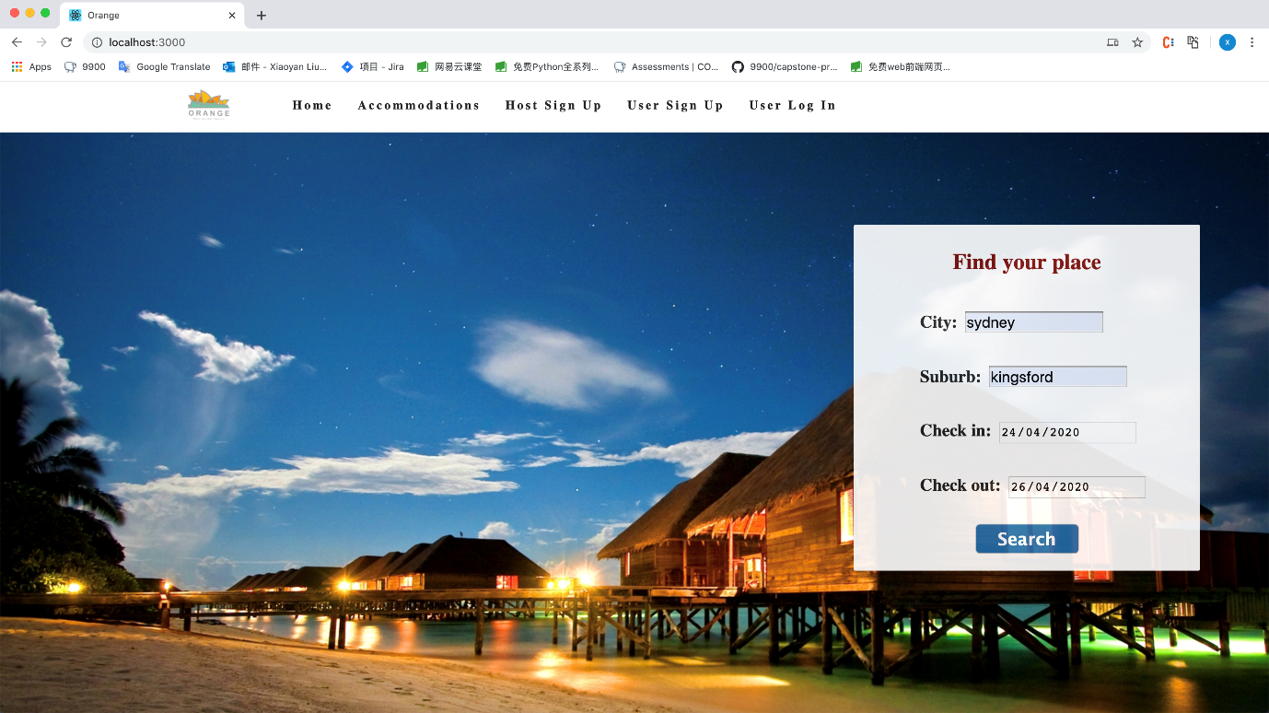

Figure 1 Homepage

When users are at homepage as shown in the picture, they need to choose city, suburb, and date of the accommodation that they want to stay, and then it will show the results. There also includes host and user account parts in the navigation bar.

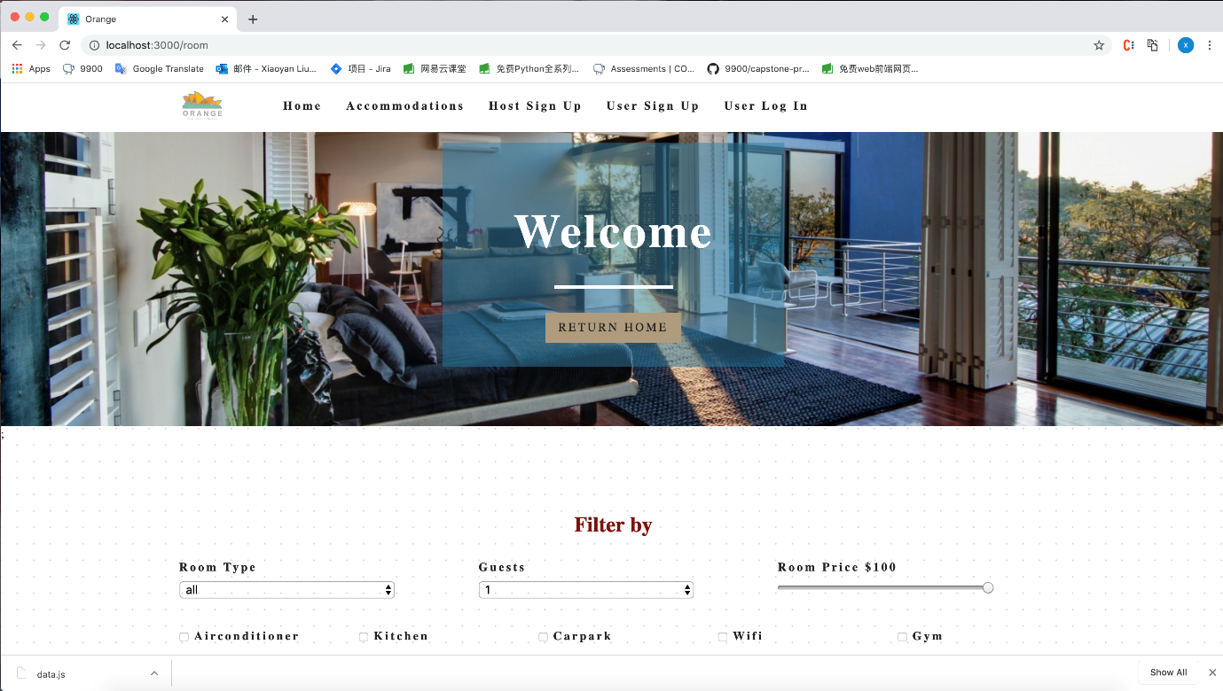

Figure 2 Search result page

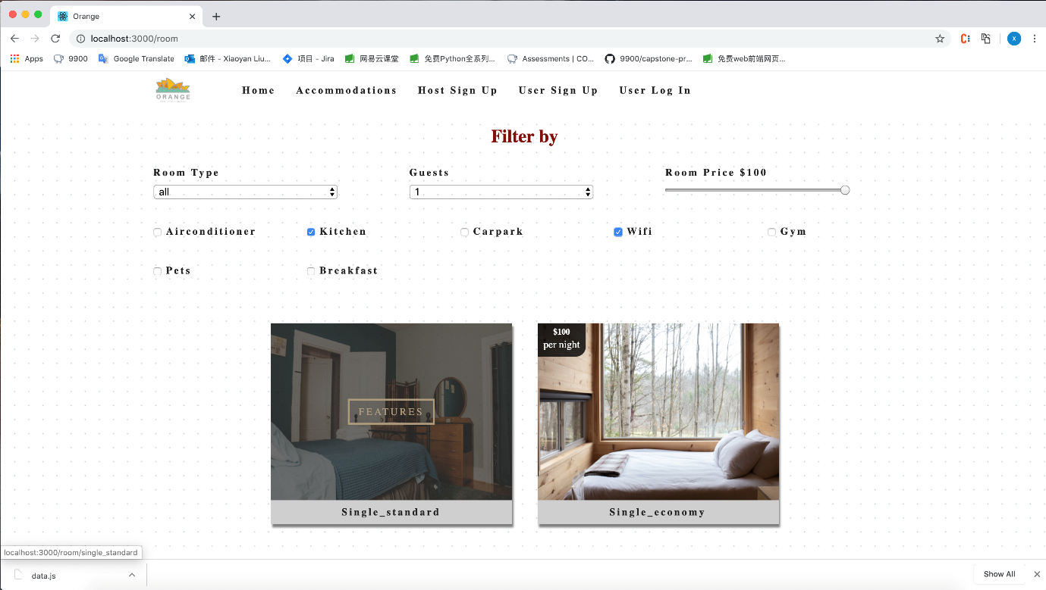

Figure 3 Search result page

When users are at rooms result page, they can choose to return to homepage clicking the ‘Return Home’ button on the top, or they can add more restriction through choosing more options in the filter area. Satisfactory rooms are shown under the filter, with price and room type on it, and users can click on ‘Features’ button to see room details.

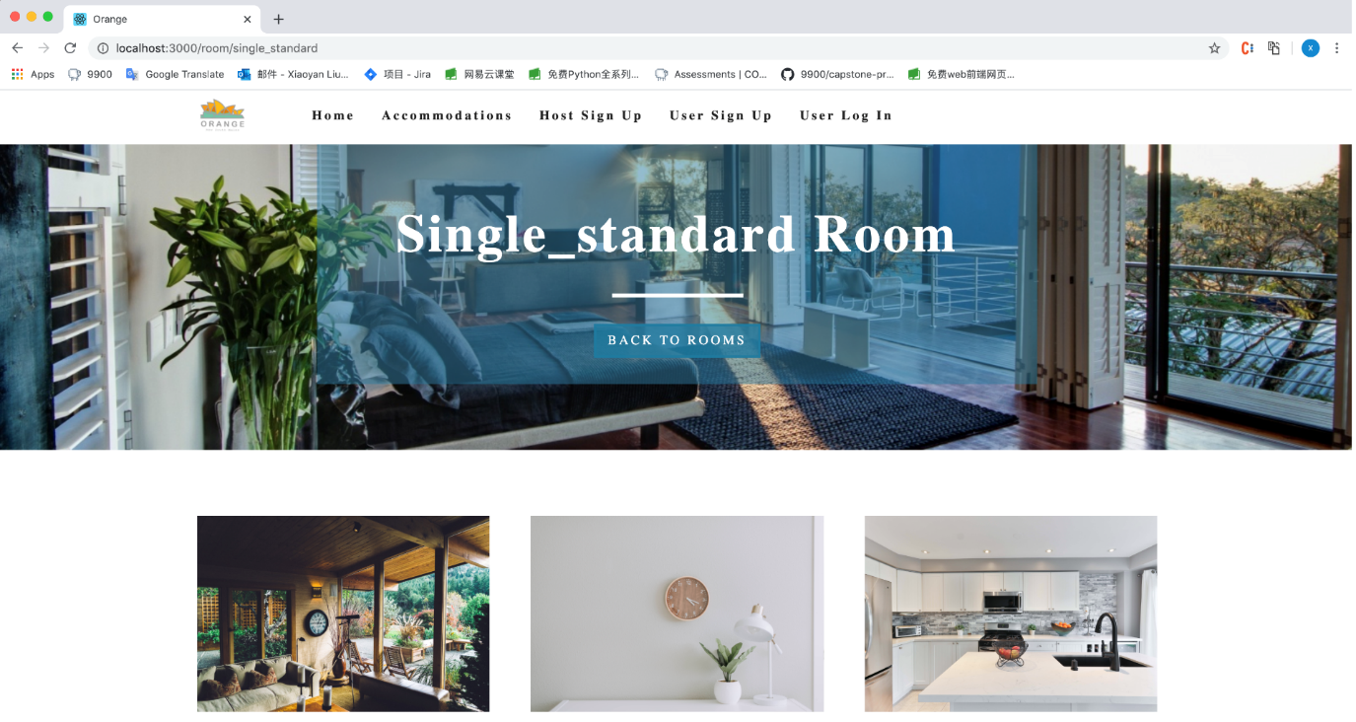

Figure 4 Room page

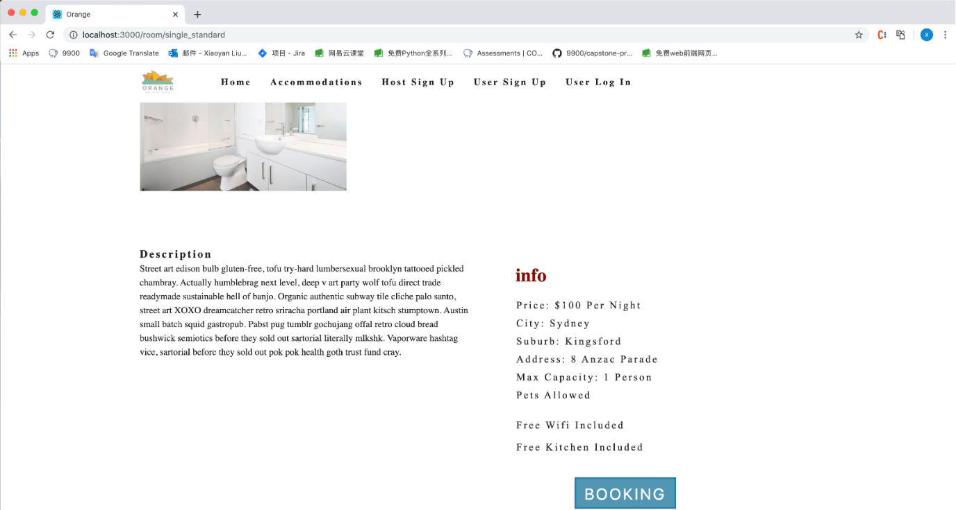

Figure 5 Room page

Also, users can choose to go back to rooms result page, using ‘Back To Rooms’ button. All room details are described in the room information part, then users can book this room through ‘Booking’ button.

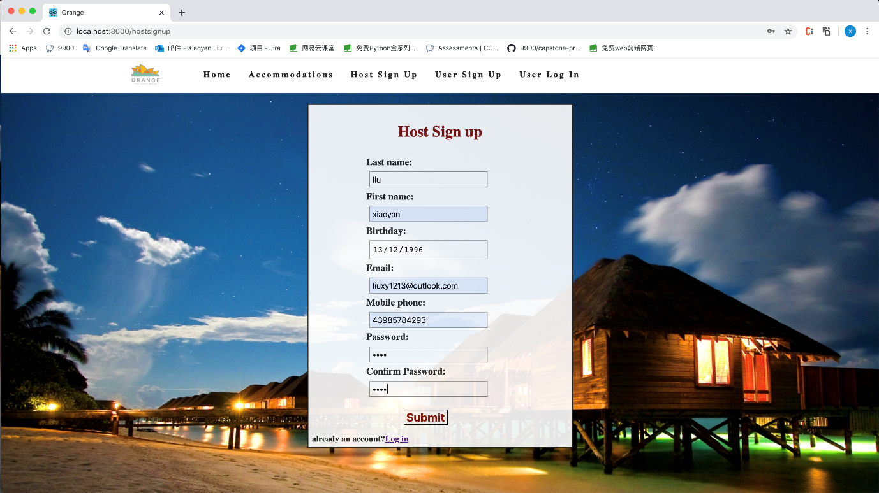

Figure 6 Host sign up page

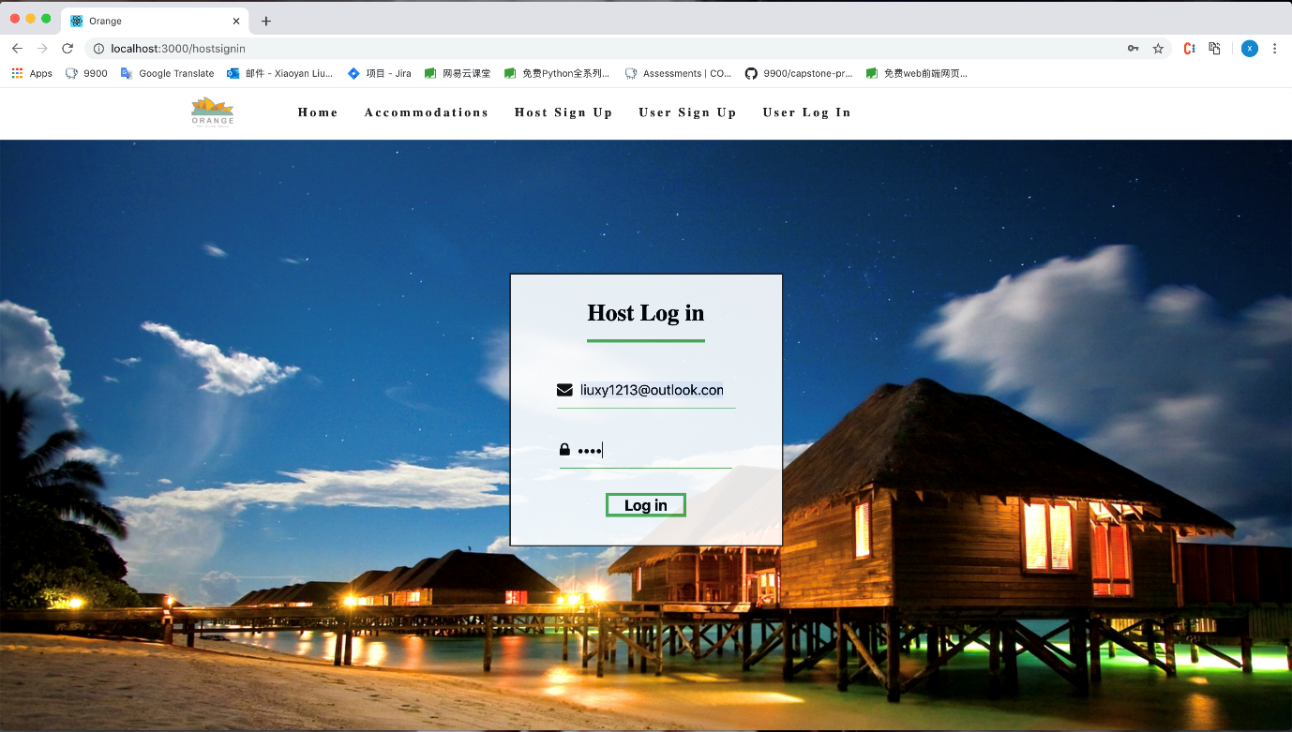

Figure 7 Host log in page

Any user needs to register for an account before booking or advertising accommodation. Back to the navigation bar of the homepage, users can click ‘User Sign Up’ to provide some details to fulfill an account and then they can log in to book rooms. Here consumers and providers are required same information to set up an account and the layout of two sign up pages remains same. After logging in, users can search again and book the room.

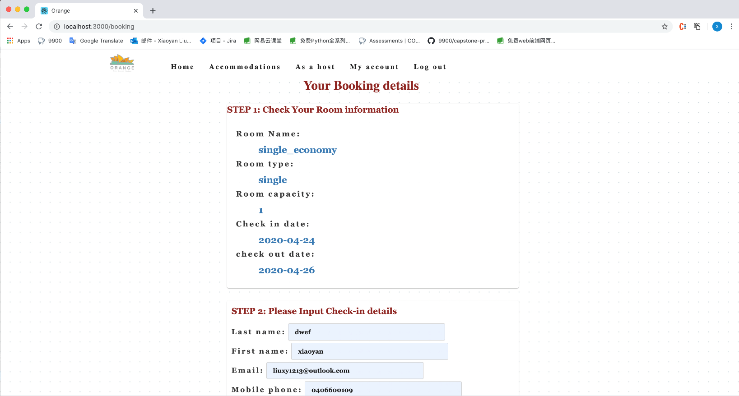

Figure 8 Booking page (1)

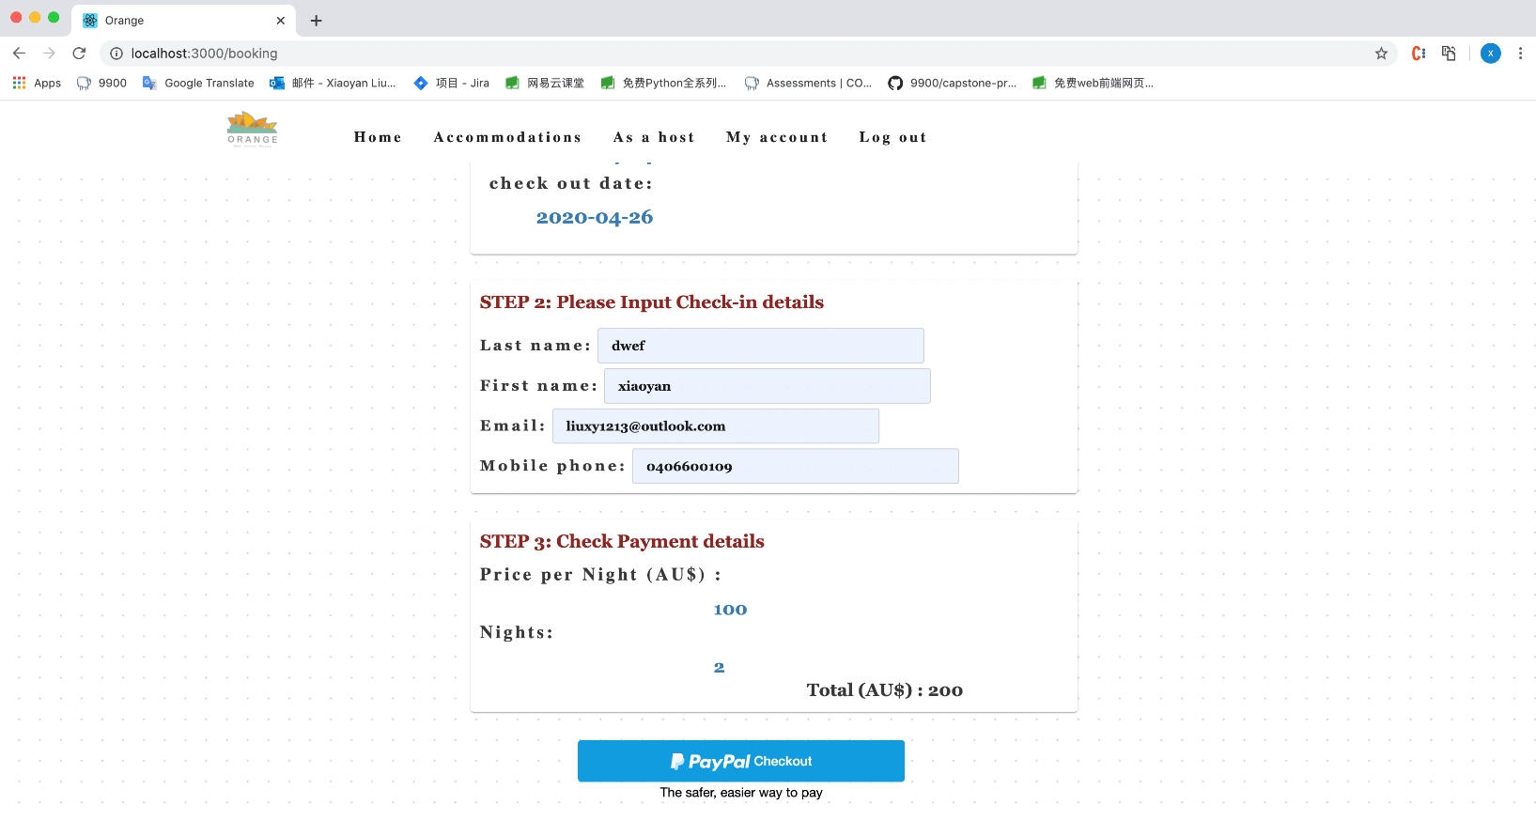

Figure 9 Booking page(2)

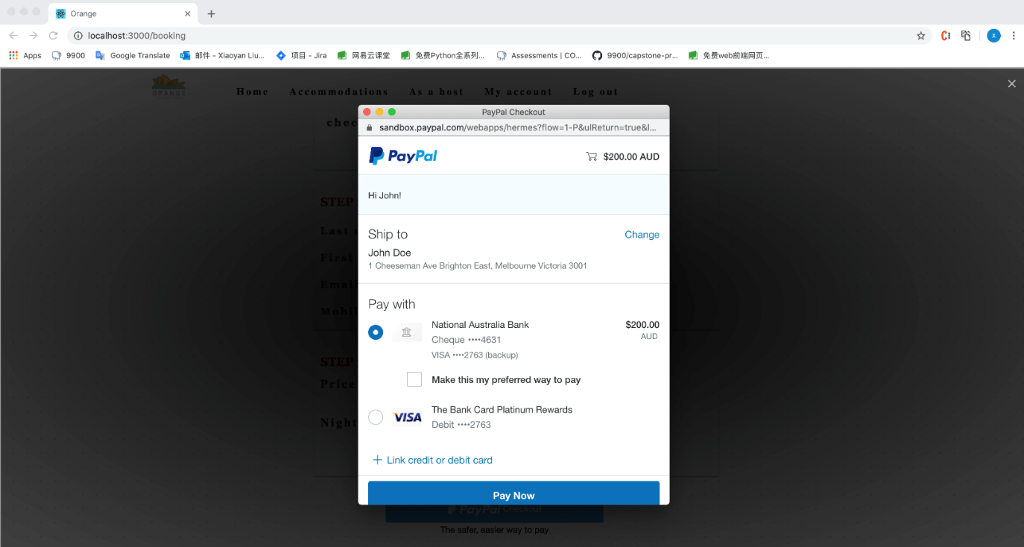

Figure 10 Check out page

Details need to be confirmed while booking. Booking information of the room will be shown for users to check again and users need to input tenement details for future check-in purpose. Then users can check out by PayPal.

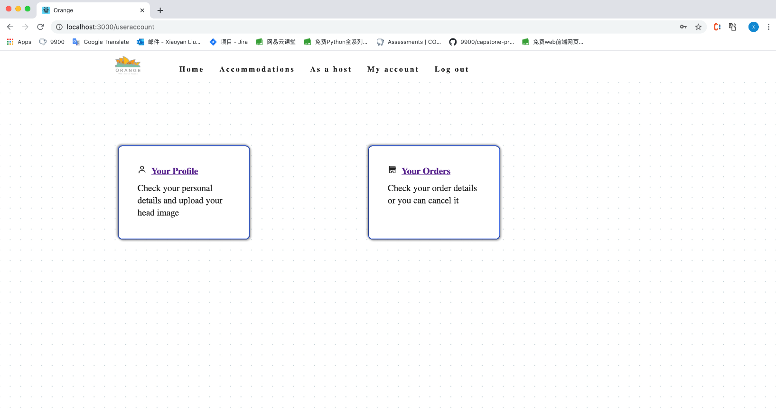

Figure 11 User page

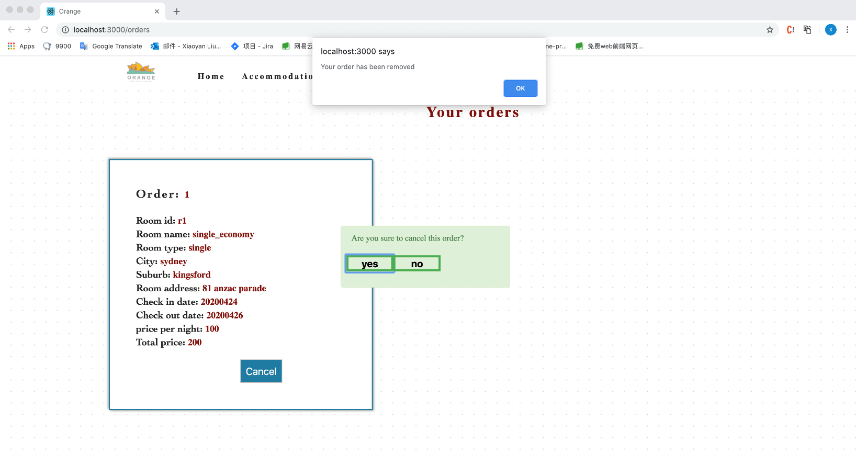

Figure 12 Order page(Cancel)

After booking, users can check their orders in account page through choosing ‘your orders’. In orders page, all booked orders will be shown and also user can cancel it if they don’t want it anymore.

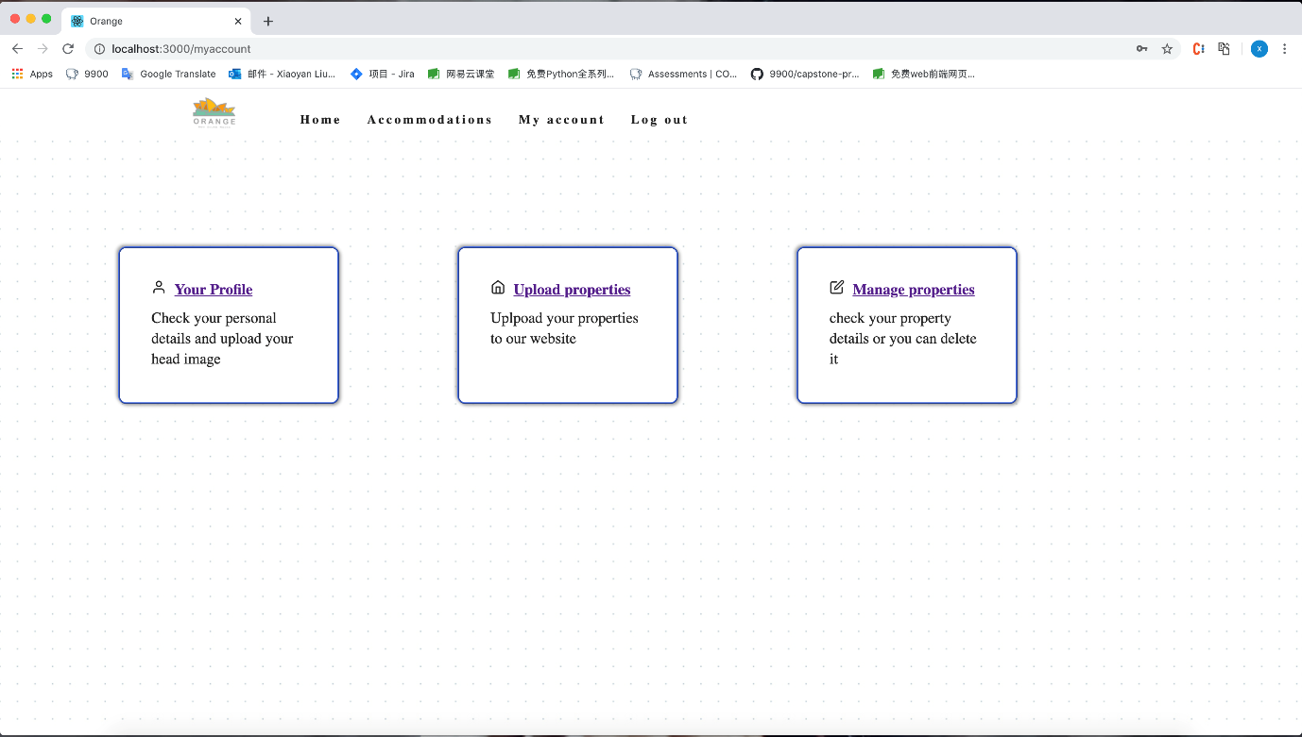

Figure 13 Host page

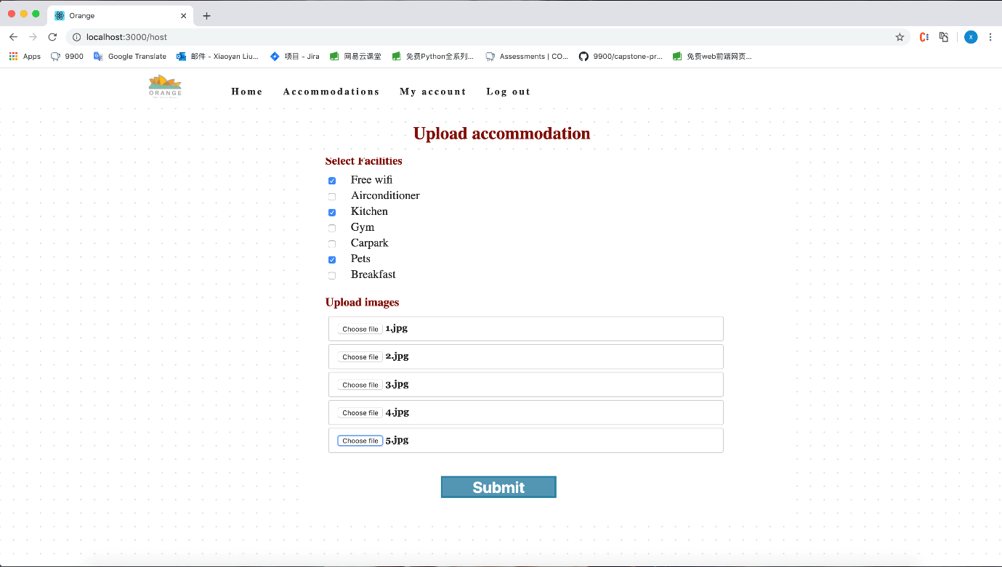

Figure 14 Upload property page

Providers can advertise their properties through clicking ‘Upload properties’ in host account page when they already have logged into their account. Finishing all the room details, users can click ‘Submit’ to upload their property to our website.

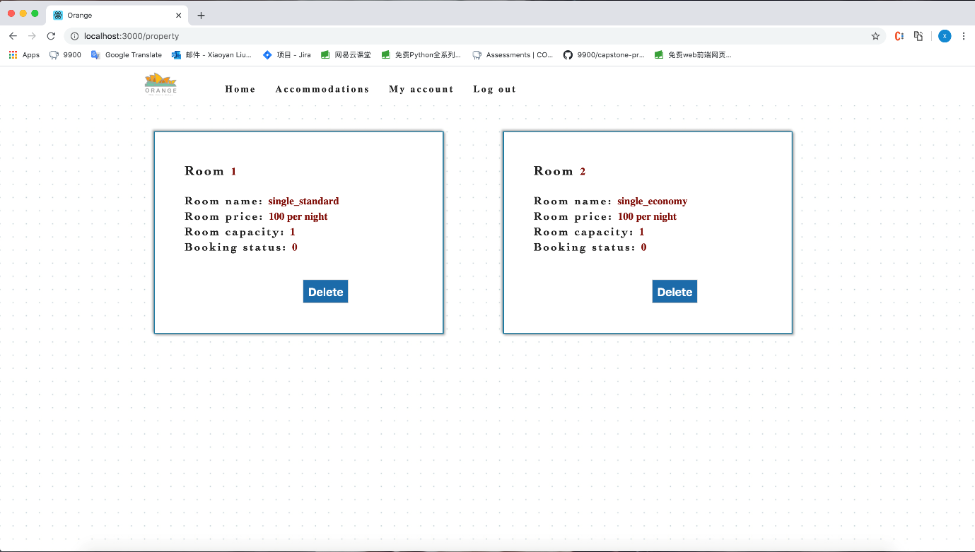

Figure 15 Property page

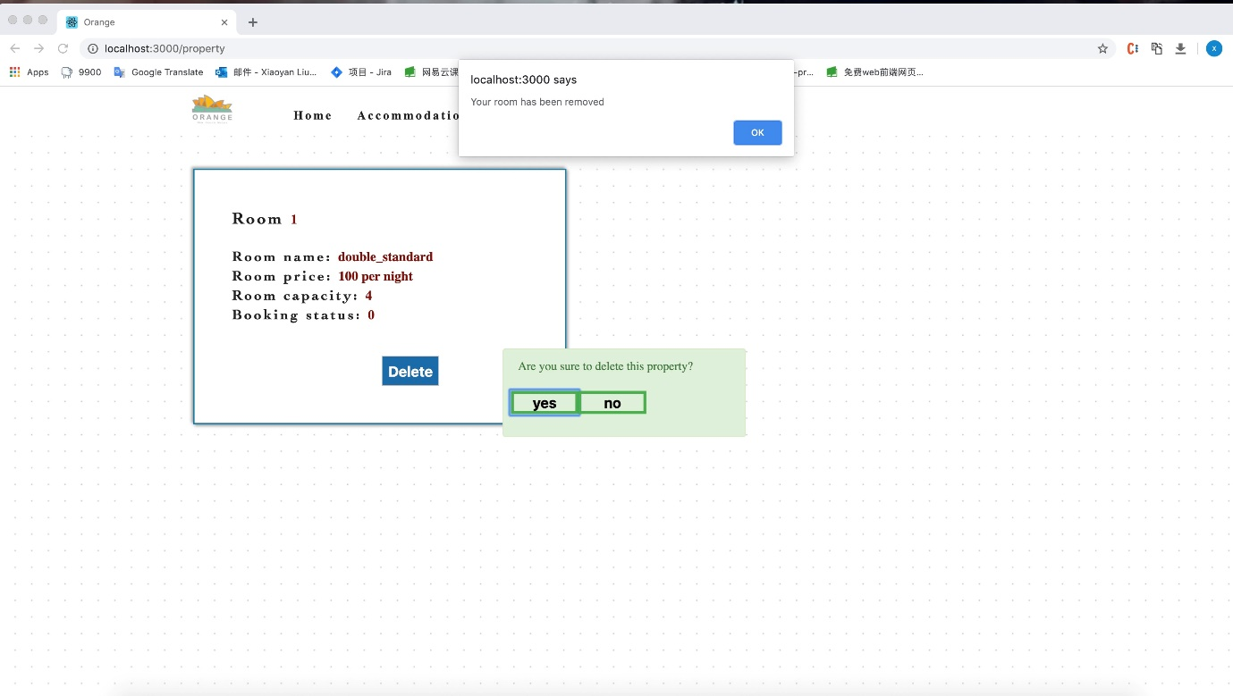

Figure 16 Property page(Delete)

Same as users, host can check their properties in account page through ‘Manage properties’ and they can delete the properties as well.

# System architecture

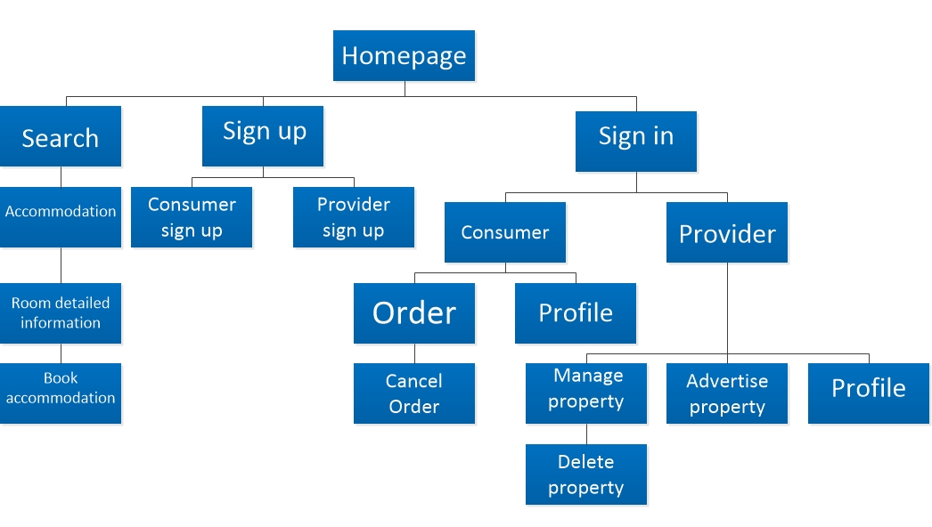

Figure 17 Front-end structure

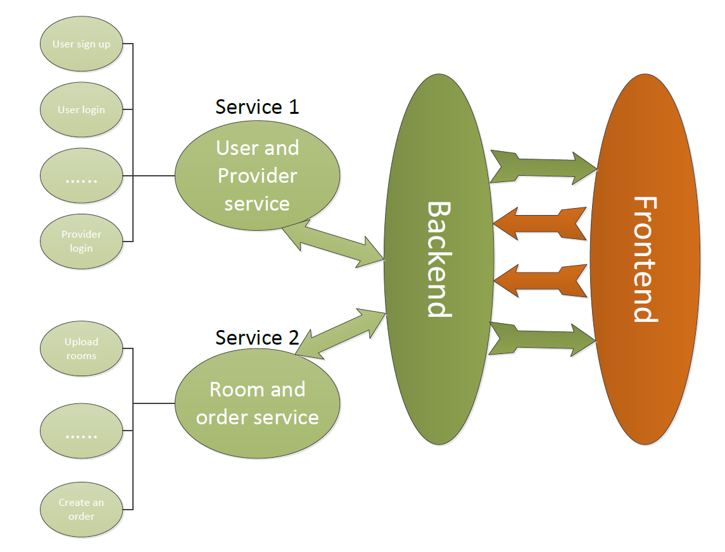

Figure 18 Back-end structure

# System functionalities

The functionalities of the website and some implementation challenges are illustrated according to the front-end and back-end that have been developed. For front-end, it’s specified through the five epics that have been set in the project proposal. For back-end, it’s specified through several API interfaces.

1. Front-end

Consumers and hosts can register an account by submitting their full name, birth, email address, mobile phone, and password. The navbar of our website will change after users log in.



Figure 19 Navbar before login

Figure 20 Navbar after Consumers login

Figure 21 Navbar after host login

Since we set a different status on different users, the navbar will guide our users where they can go. We have authentication for users want to book a room or upload a room. Providers need to log in if they want to advertise their properties or update them.

Consumers can look through any rooms on our website without an account, however, they must have an account if they want to book accommodation. After login, Different users have different account interface. Consumers can watch their profile, check their orders, or cancel their orders in my account.

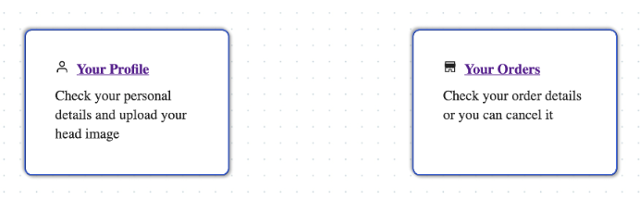

Figure 22 Consumer account

Providers can watch their profile, upload their property, and manage the property. 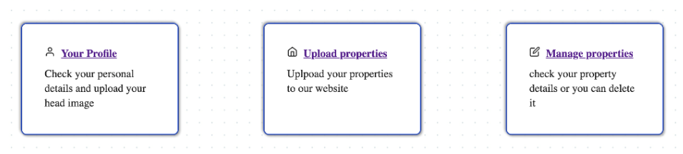

Figure 23 Host account

Our website is aiming at properties within the NSW area. The consumer can select the city, suburb, and check-in/out date at the search module on the home page. We set a limit on city and suburb input. When users input other area’s properties, the website will not respond to anything.

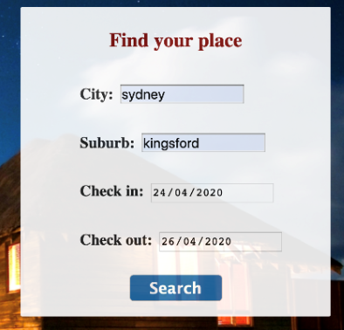

Figure 24 Search module

And then, they can select a room type, guests’ number, ideal room price, and wanted facilities to filter the room they want. Our website can represent rooms that achieved the filter. 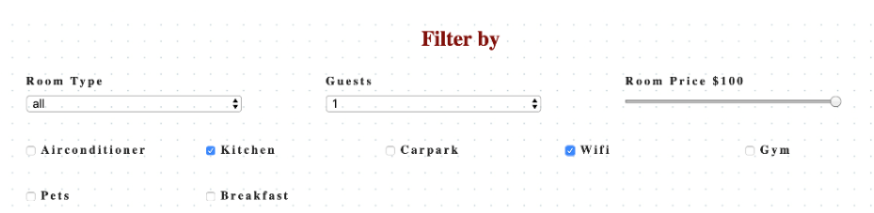

Figure 25 Filter module

Our website represents each room feature concise and clear. We only represent the most important information about the room on the room information page, such as room images, price, facilities, description. For image, users can zoom it in to more clear about the room details. It will not waste consumer’s too much time to make a decision. Consumers can book the room easily by clicking the booking button.

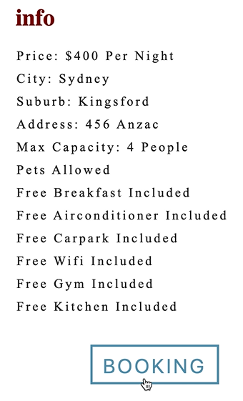

Figure 26 room info

On the booking page, there are three steps to guide users. Consumers can check the room’s name and check-in/out date at setp1. And then input guest information on step2. Finally, they need to confirm the total price and then use PayPal to pay for their booking. We choose PayPal as our payment since it is worldwide, high security with really strict censorship.



Figure 27 PayPal button

In epic 4, providers need to upload the details of the proterty, including type, name, address, price etc. The key point is that the data formats pass from the front-end must be equal to the data formats receive from back-end.

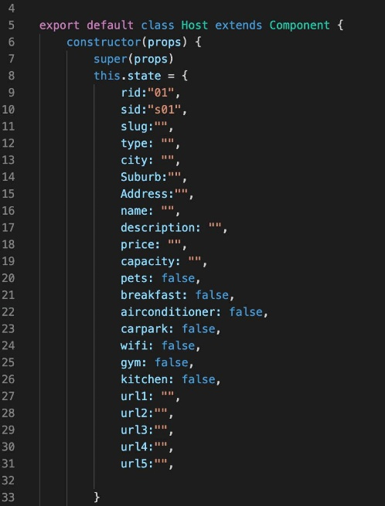

Figure 28 Property information

As shown in the figure, the basic information and picure urls are in type of string and the facilities of the property are in boolean.Then we use post method to send data to API with the url of “http:127.0.0.1:8081/v2/room”. And if provider upload successfully, it will remind a ‘succeed’ hint.

In the proposal, hosts are supposed to be able to modify their property through a ‘Modify’ button on the host page, but during the development, due to the difficulty of this function and lack of time, we didn’t complement this function. We assume that when hosts click ‘Modify’ button, it will direct to upload property page filling with existing property information, and hosts can make some modificaitons then submit. Modified properties can be checked through ‘Manage Property’. But it’s hard to get data from existing page and then show them on a new page. The data format like boolean for facilities and url for images are difficult to be transferred.

Here we suggest that if hosts want to modify their properties, they can directly delete the property and upload again. It will be fixed in the next stage of the development of our website as a future improvement.

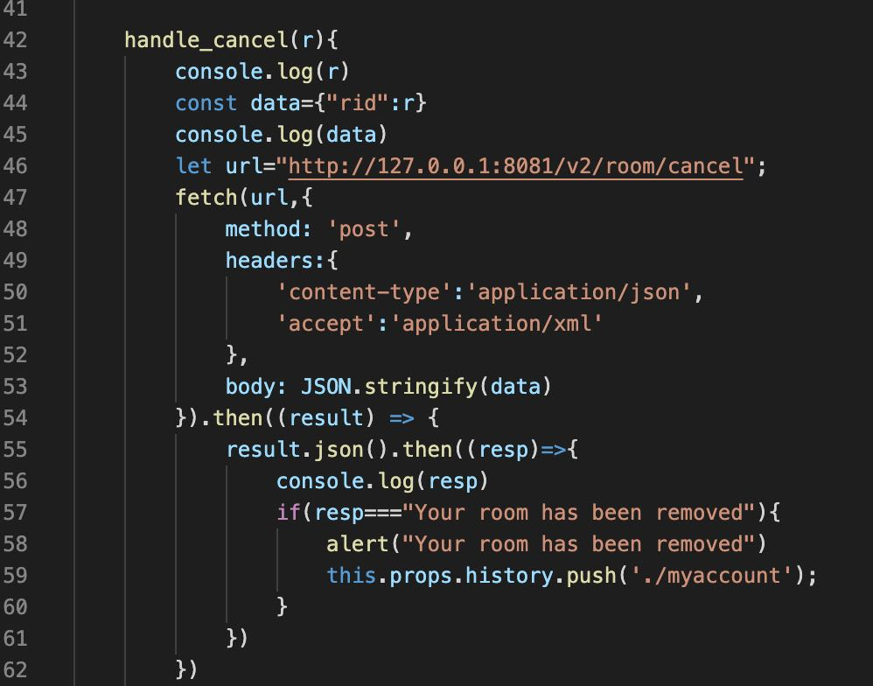

Figure 29 Delete room

For deleting the property, we use post method to request back-end through API and we use room id to judge which room is to be deleted. Then we use push method to jump the page to the provider account which implement the refresh prograss of this function.

1. Back-end

We use Python-flask as our back-end application base. In this demonstration, we run the service locally, but it can easily upload to a cloud and performed as a normal website. The whole project is structured in three parts: model, view, and controller.

This project adopted Flask-Restful to build API service. We host two services, one is ‘User and Provider service’, this service is focused on the user register, like sign up, login, and so on. Another one is ‘Room and order service’, which is focused on room information and status, can provide various functions like upload room information or create an order.

Some API interface shows as follow:

<http://127.0.0.1:8080/v2/user> – User sign up, using post method, storing user information in the database

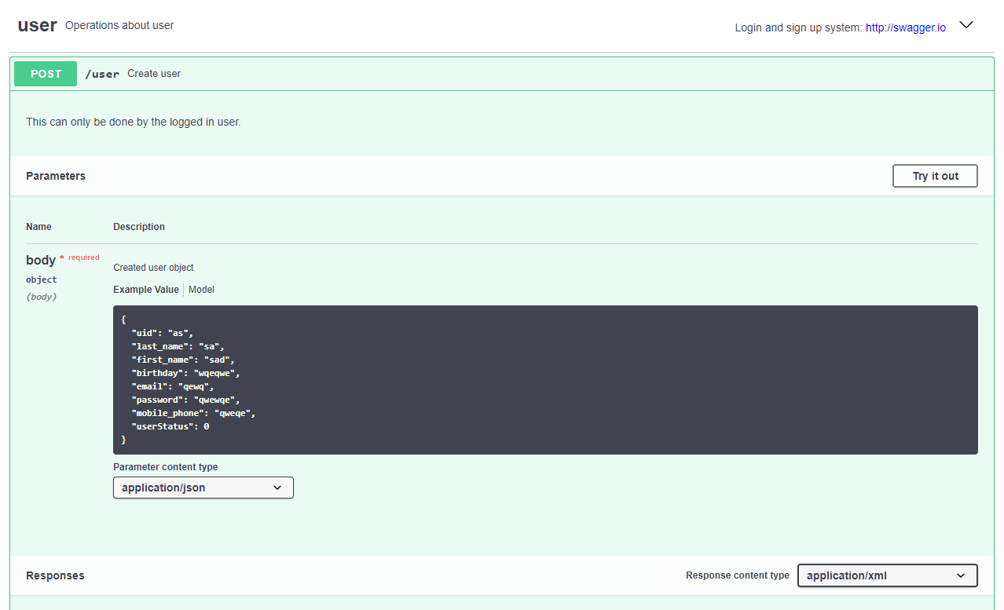

Figure 30 User sign up, send user data to store in database

<http://127.0.0.1.8080/v2/user/login> – User login, change userStatus value in database, so we can monitor user’s status

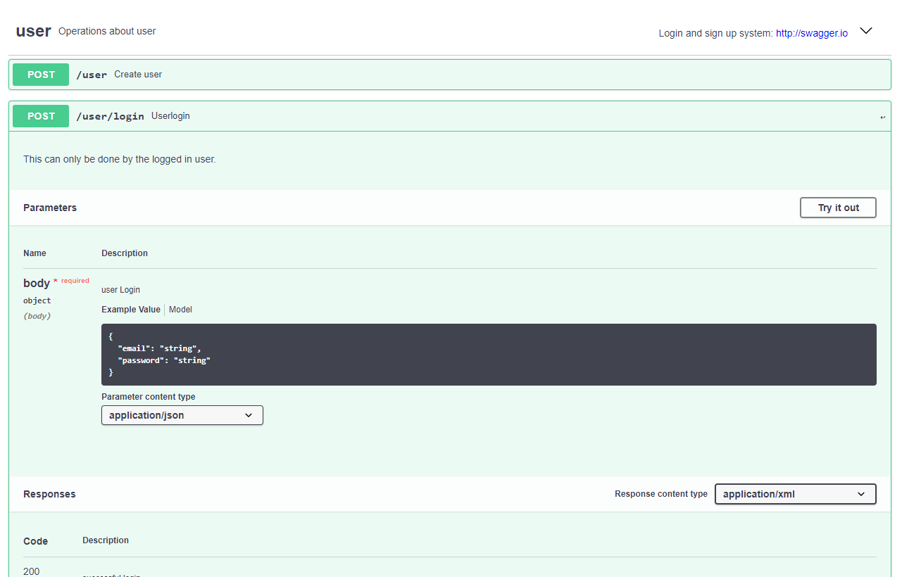

Figure 31 User login, change status in database

<http://127.0.0.1.8080/v2/user/logout> – User logout, using get method, get userStatus data from database

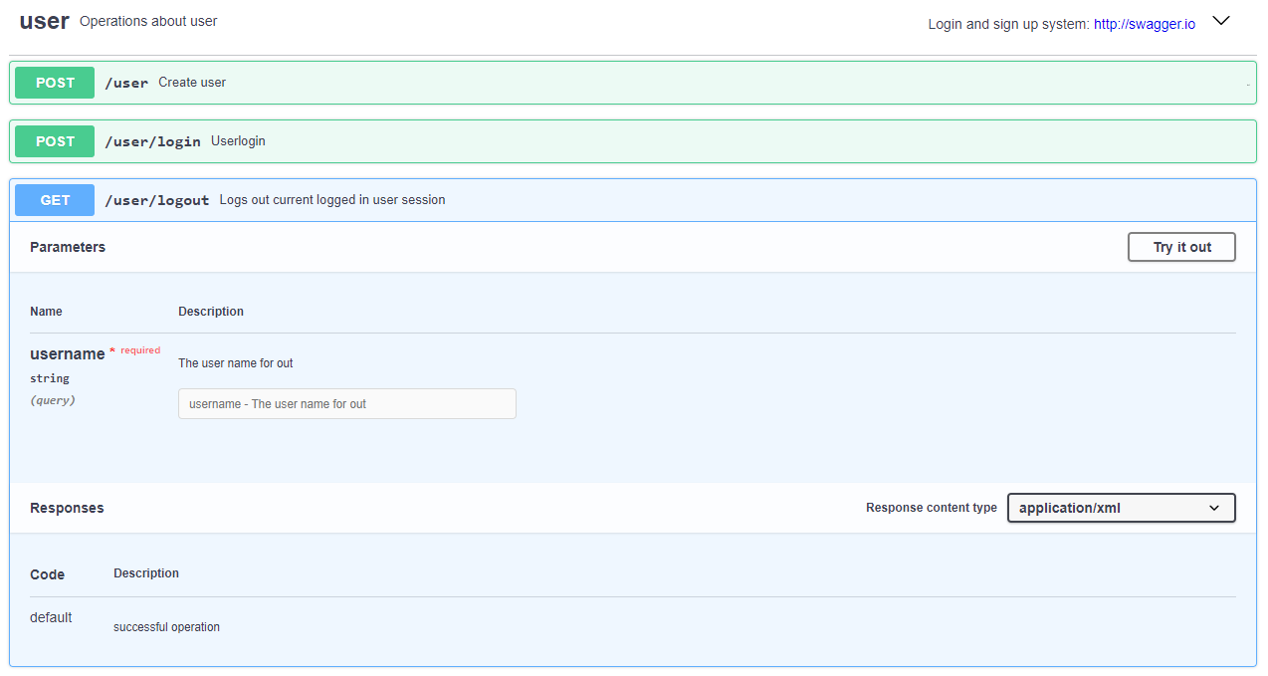

Figure 32 User logout, check the user’s status in database

<http://127.0.0.1.8080/v2/user/info> – Get user information

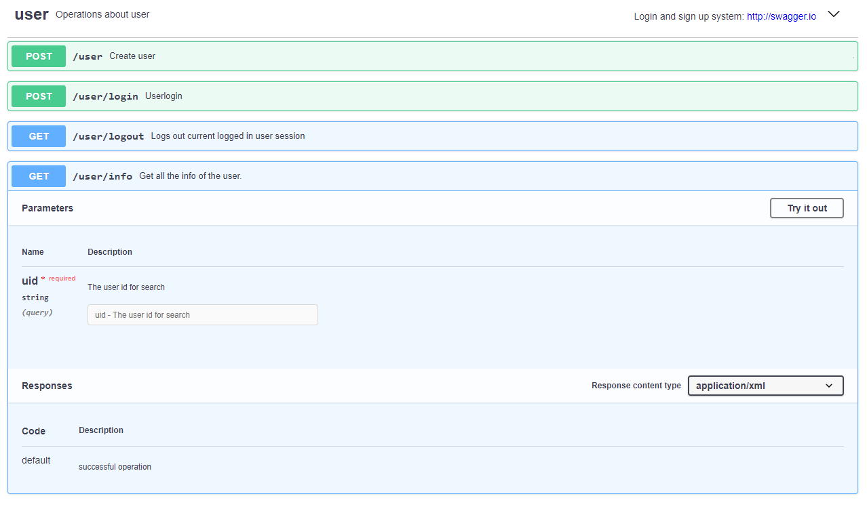

Figure 33 Get user information

[http://127.0.0.1.8081/v2/room](http://127.0.0.1.8081/v2/room/info) – Room information can upload in this port

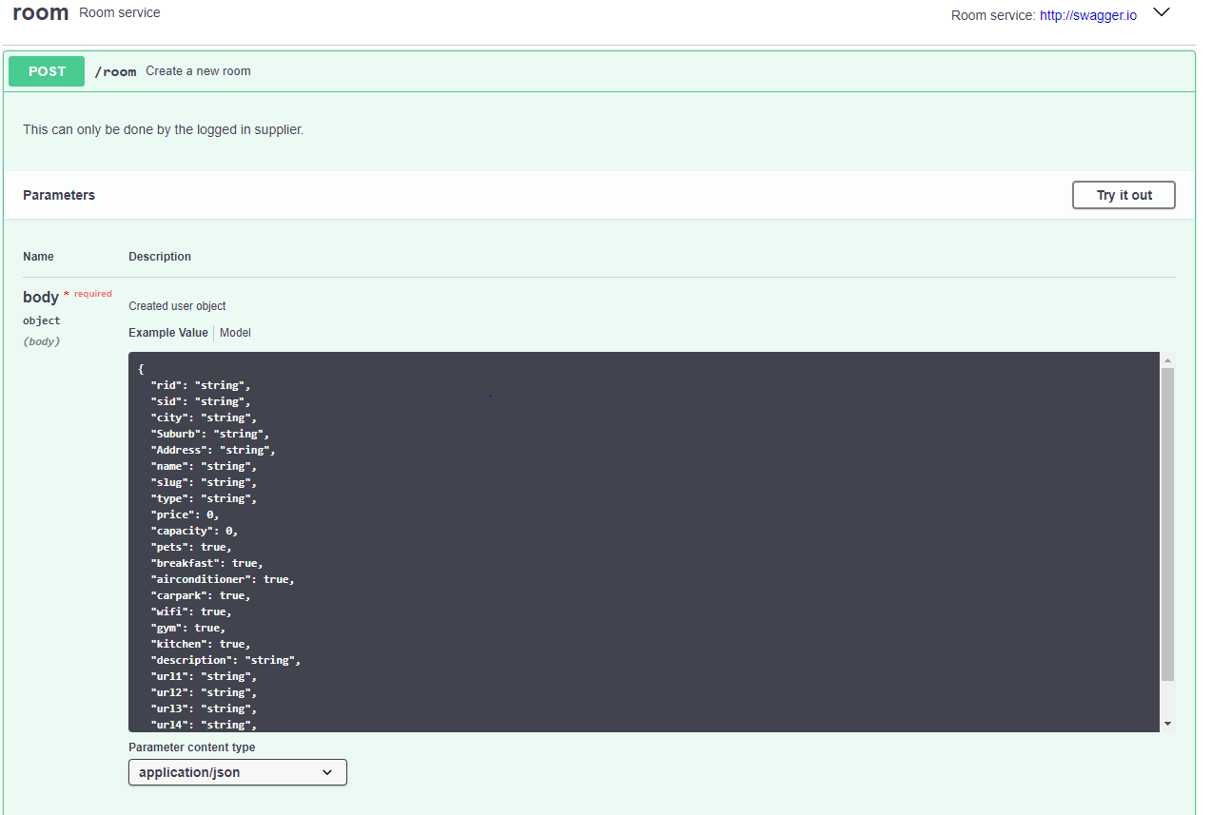

Figure 34 Room’s information upload

<http://127.0.0.1.8081/v2/booking> – After booking a room, change the room status information in database

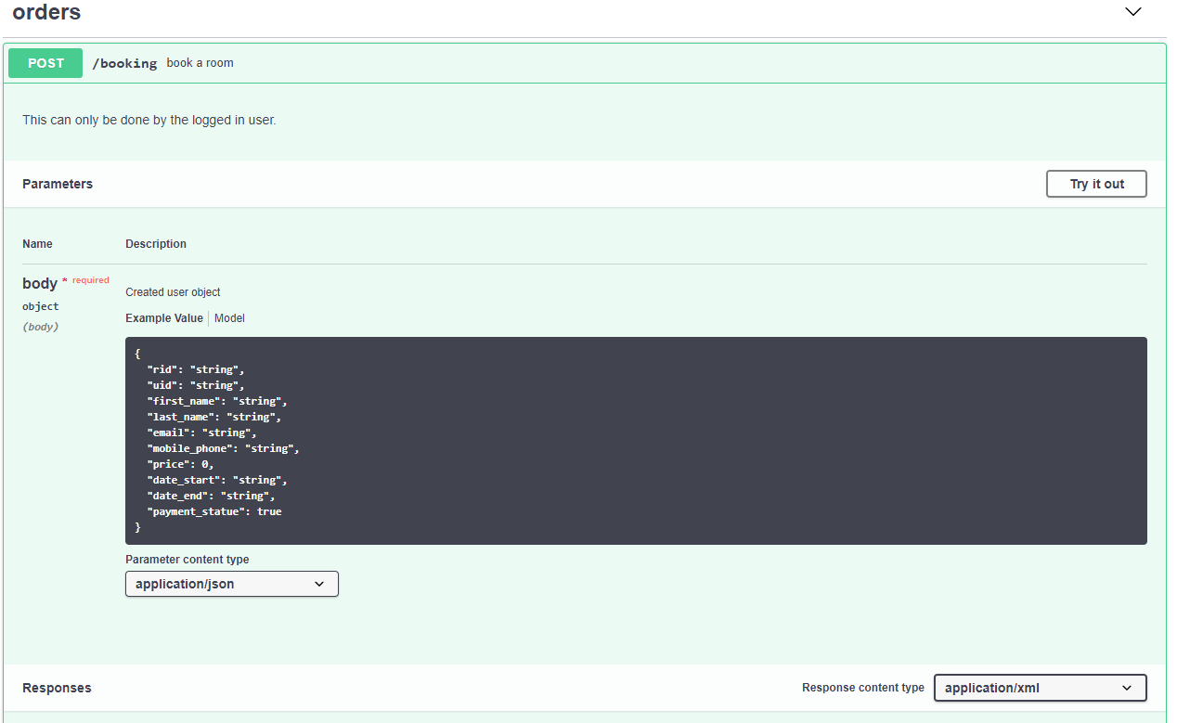

Figure 35 change the room’s status information in database

# React modules

In this project, we mainly use React as our front-end tool. React is a user interfaces building tool based on JavaScript library. We have used lots of react internal libraries in our project and import some external libraries for interface and function improved. These are some external libraries.

* material-ui (Material-UI: A popular React UI framework, 2020)- a user interface library that includes many components for the user interface. we have used a basic grid to design our layout on the booking page with modifying on the source code to satisfy our demand. The grid component can help us to locate each part on the page more easily.
* PayPal (react-paypal-express-checkout, 2018)-PayPal as a third-party online payment system is easier and safer for customers to pay the accommodation order. We have used it at the booking function.
* Axios (axios, 2020)– a library we used to get external resources from URL (set by back-end).
* antd (Upload - Ant Design, 2020) - we have imported this upload component to upload an image as an avatar for the profile of user and provider.
* react-icons (React Icons, n.d.) – a library with lots of different icons. We have used some icons in this library to beautify our website.
* Noty (noty, 2018) – a notification library that can be used to create some notification messages to replace standard alert dialog. We have used it at orders and property pages for user confirming their operation.
* Zmage (react-zmage, 2020)– a component for the image. We have used this to replace <img> at room information part which makes users can zoom the image in.

# Implementation

### Challenge

1. We met some problems about the connection between front-end and back-end at the beginning due to the lack of group member communication. For instance, the data format our back-end developers need is a list with every element in the list for json format, but what our front-end developers pass is string format. Later we keep more close contact and discuss about the issues and finally figure it out.

2. When we are dealing with orders and properties page, we firstly use drop-down list with a list linked to the ‘My account’ in the navigation bar on the top. But later we find that as it’s a function module to implement the drop-down list, it’s hard to get data in a function to show the orders and properties that made by users, so we use class module to get data which is through click buttons in the account page and jump to relevant pages.

3. When users take actions to their orders or properties, we firstly set a ‘refresh’ button for them to click in order to update the page to show new information if they cancel order or delete property, but as suggested by our tutor, it violates the usability principles of user experience. So we decide to change it that we use ‘history.push()’ to jump page to the user account then they can access the order or property again, and the function of cancel and delete is finished.

### Tricks and special design

1. On accommodation and room information page, the header background was upload by the host at upload accommodation page. We choose the wonderful one as each room’s header background. Customers can see it immediately when they click into one room’s feature on the accommodation page.

2. when providers upload accommodation, they can only select room name form what we set rather than input random room name. We set the room name according to room type which is easier for our website management. The provider doesn’t need to worry about naming their accommodation. Customers can know what kind of room form the room name directly. The same type of room has the same name, so every room has an equal chance to be picked by customers.

# Future Improvements

1. We can enrich our website to make it general enough to be adapted for similar services,

for example, for selling and buying products. So we may need to adapt the user interfaces for both consumers and providers and add some constraints when providers upload different items.

2. We can figure out the get data method and add modify property function for providers in the future. It will help providers to maange their properties more efficiently, without deleting them and upload again.

# User documentation

**Back-end**

Request packages:

Python3

Flask

Jinja2

Flask-RESTful

jsonschema

six

SQLite3

Running environments:

Docker

Deploy:

Run Docker in your computer

#Create Service1 folder

$ docker build -t Service1

$ docker run -p 8080:5000 -t Service1 run this service on port 8080

#If this is your first time run this code, it will downloading package, and set environment for you. Also the service1 will open at port 8080.

#Create Service2 folder

$ docker build -t Service2

#Open Service2 at port 8081

$ docker run -p 8081:5000 -t Service2 run this service on port 8081

**Front-end**

npm version = 6.13.4

node version = 12.16.1

npm install:

Download the required npm modules that list in the reference or can be found in the package.json file in the project, like material-ui, react-icons, axios, ant-design and antd.

npm start:

Run the website in the development mode.

Open http://localhost:3000 to view it in the browser.

The page will reload if you make amends. You will also see any lint errors in the console.

# References

* Reactjs.org. n.d. *React – A Javascript Library For Building User Interfaces*. [online] Available at: <https://reactjs.org/> [Accessed 26 April 2020].
* Material-ui.com. 2020. Material-UI: A Popular React UI Framework. [online] Available at: <https://material-ui.com/> [Accessed 25 April 2020]. Ant.design. Upload - Ant Design. [online] Available at: <https://ant.design/components/upload/#components-upload-demo-avatar> [Accessed 21 April 2020].
* npm. 2018. React-Paypal-Express-Checkout. [online] Available at: <https://www.npmjs.com/package/react-paypal-express-checkout> [Accessed 21 April 2020].
* npm.2020. Axios. [online] Available at: <https://www.npmjs.com/package/axios#axiosdeleteurl-config-1> [Accessed 25 April 2020].
* npm. 2018. Noty. [online] Available at: <https://www.npmjs.com/package/noty> [Accessed 25 April 2020].
* npm. 2020. React-Zmage. [online] Available at: <https://www.npmjs.com/package/react-zmage> [Accessed 25 April 2020].
* React-icons.github.io. n.d. React Icons. [online] Available at: <https://react-icons.github.io/react-icons/#/> [Accessed 25 April 2020].